**Lab report #11**

**Sadovskaya Veronika**

GitHub: <https://github.com/sdveronika/DataMola22>

**Task 1 – Loading to SAL Layer Data**

Select from table sal_cl.order_fact where order_id between 270817 and 270821, because they are in partition quarter_1 we will change:

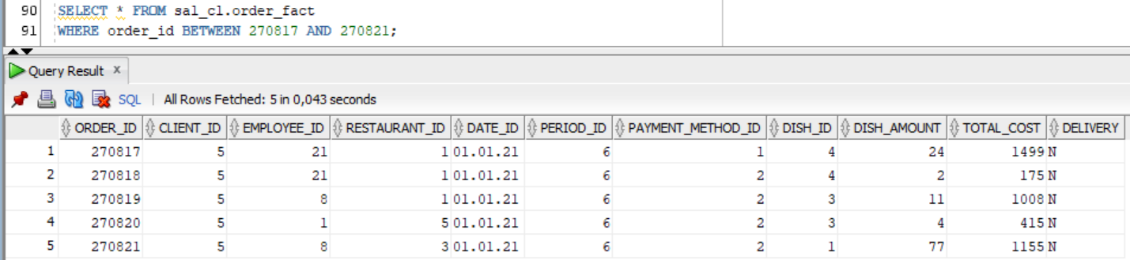

Create table that will store our entire partition, which we will change:

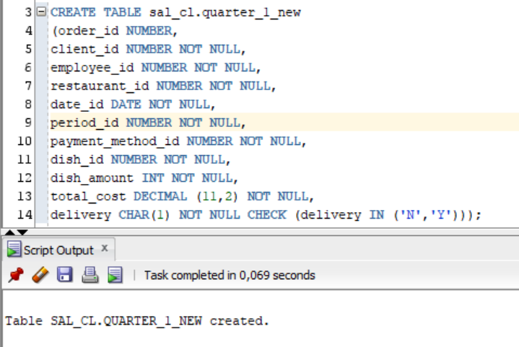

Let's update the data in the table, so that later we can see the result of replacing the partition:

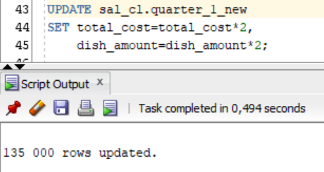

Making a partition replacement in the original table:

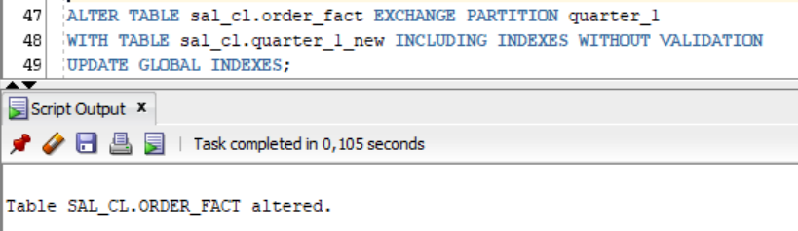

Replacement result:

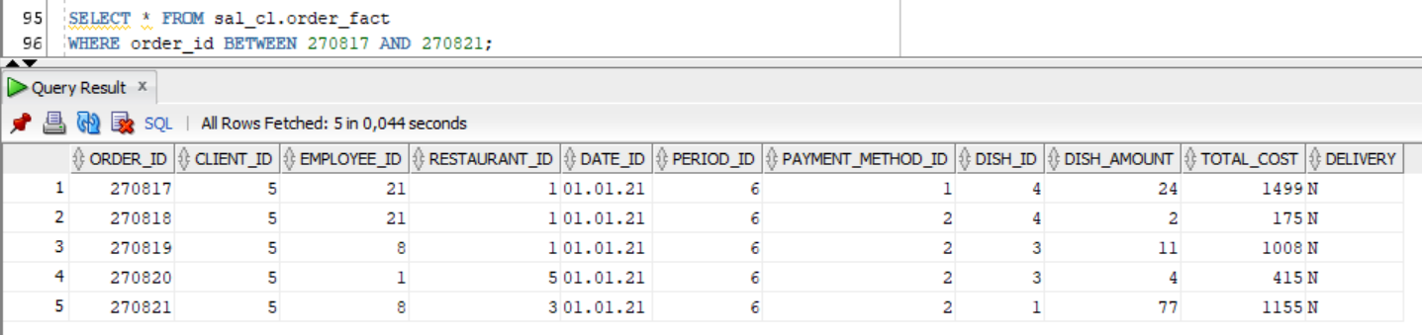

Let's merge 2 partitions into one:

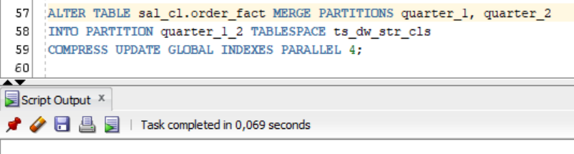

Extract data from a new partition:

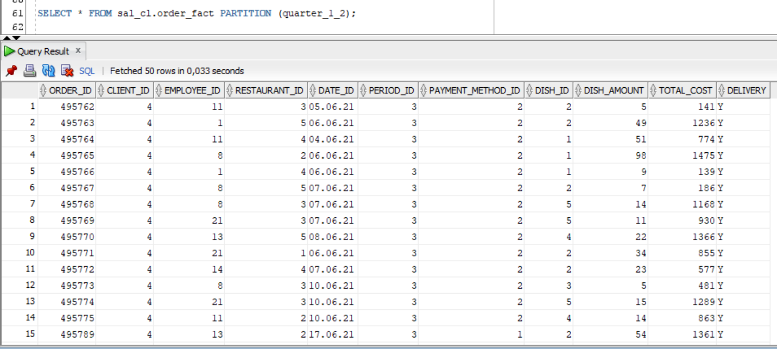

**Task 2 – Prepare Report Layout**

Let's execute a query from lab 2, which counts the number of times each item was bought(data is taken from the sa level):

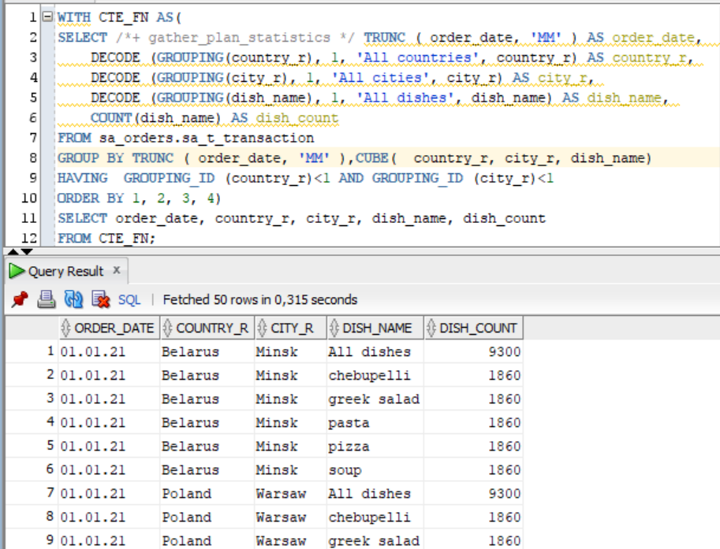

Now let's demonstrate the same query, but using tables from the dw level (star scheme). Tables are joined using left joins:

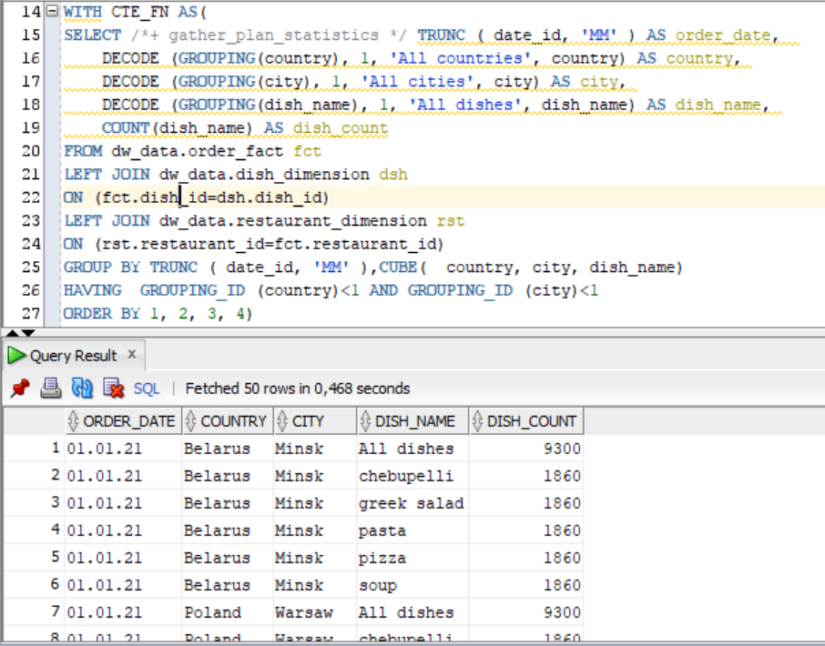

Let's compare the explain plans of both queries.

Explain plan of query from lab 2:

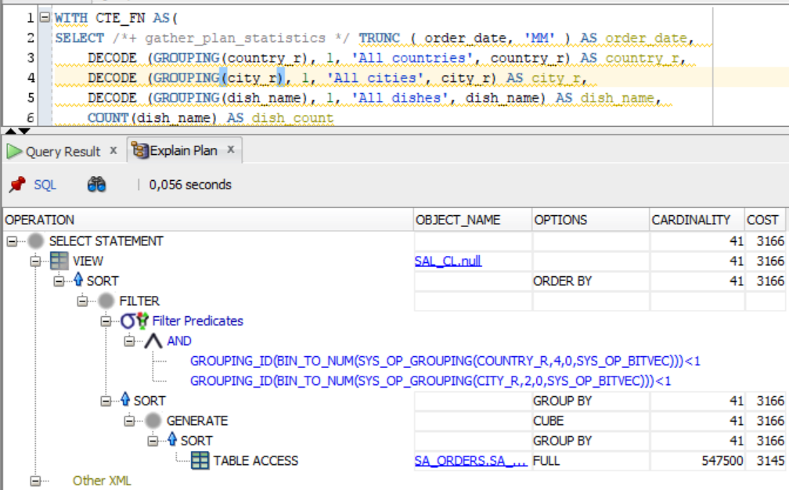

Explain plan of query from lab 11:

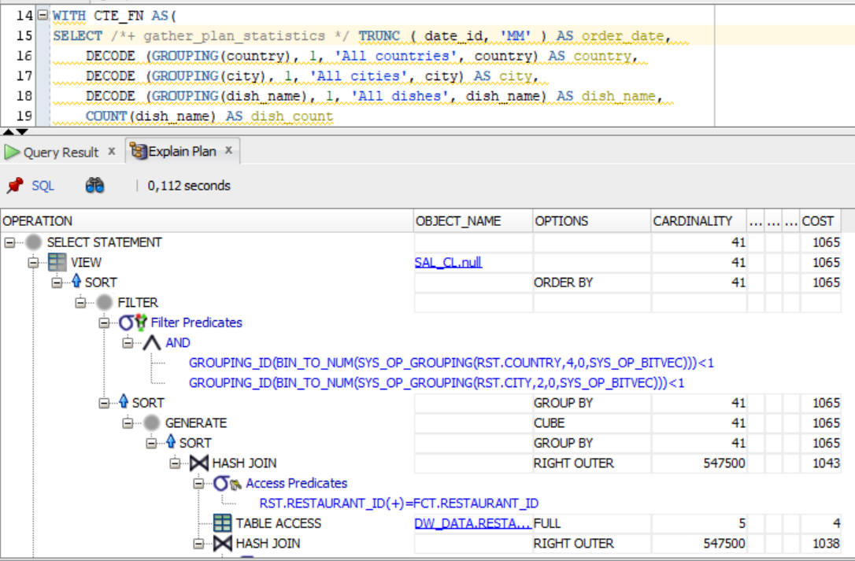

From the screenshots, it can be seen that the cost has decreased by almost 3 times, although the execution time has slightly increased.

**Task 3 – Compare Report Layout Performance**

Let's compare 3 queries that get the quantity of each item found in orders:

1. Lab 2, sa level, advancing grouping

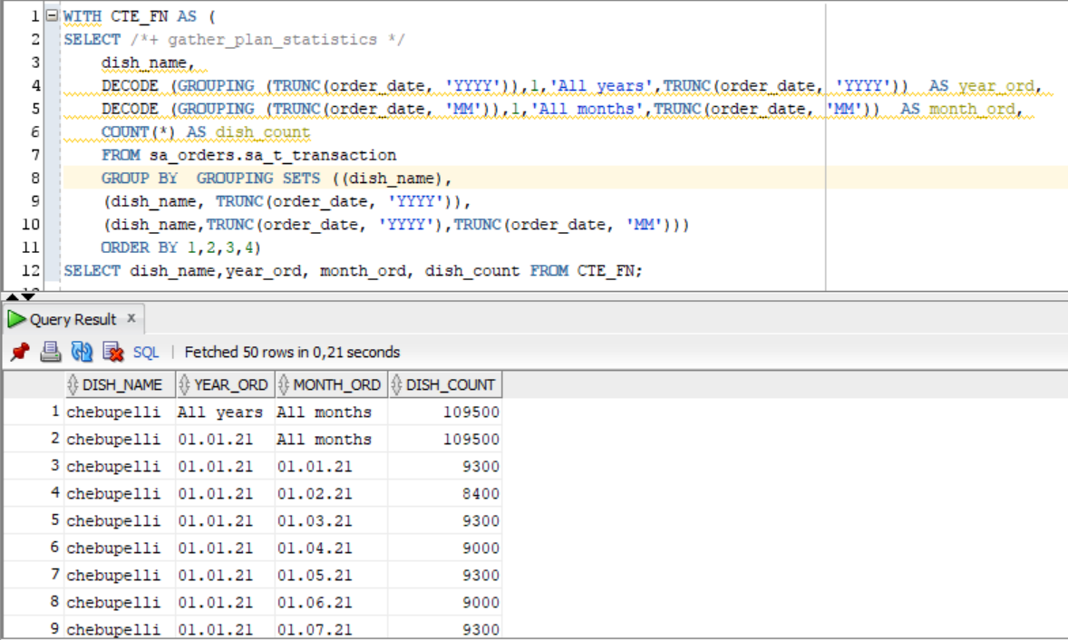

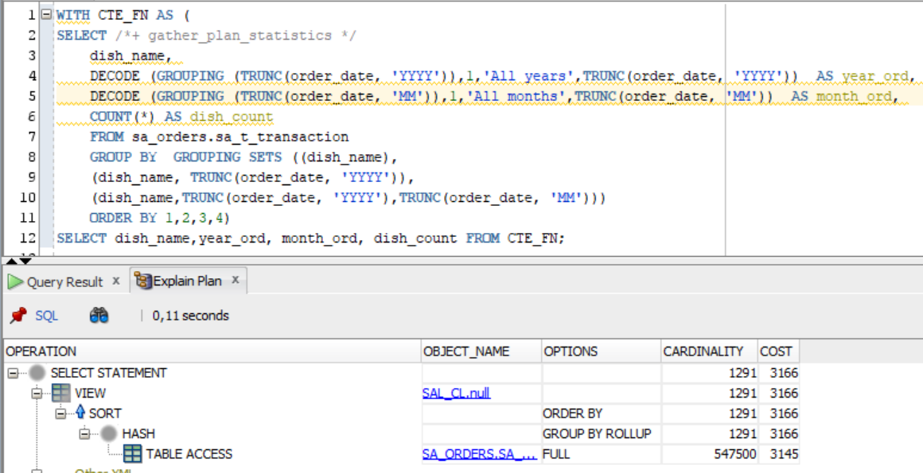

1. Lab 5, sa level, model clause:

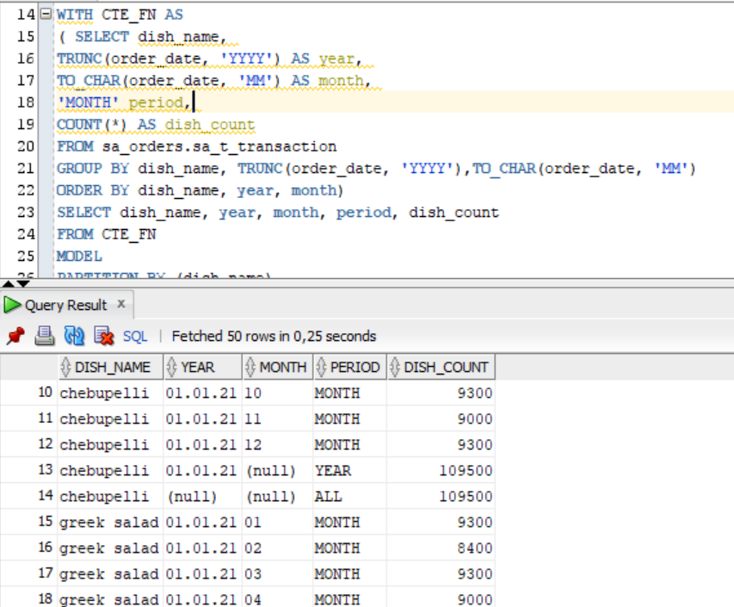

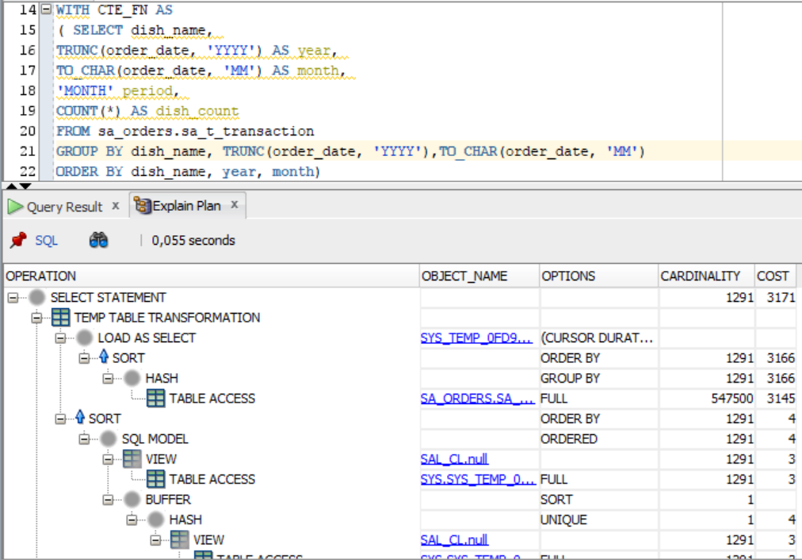

1. Lab 11, dw level, star scheme:

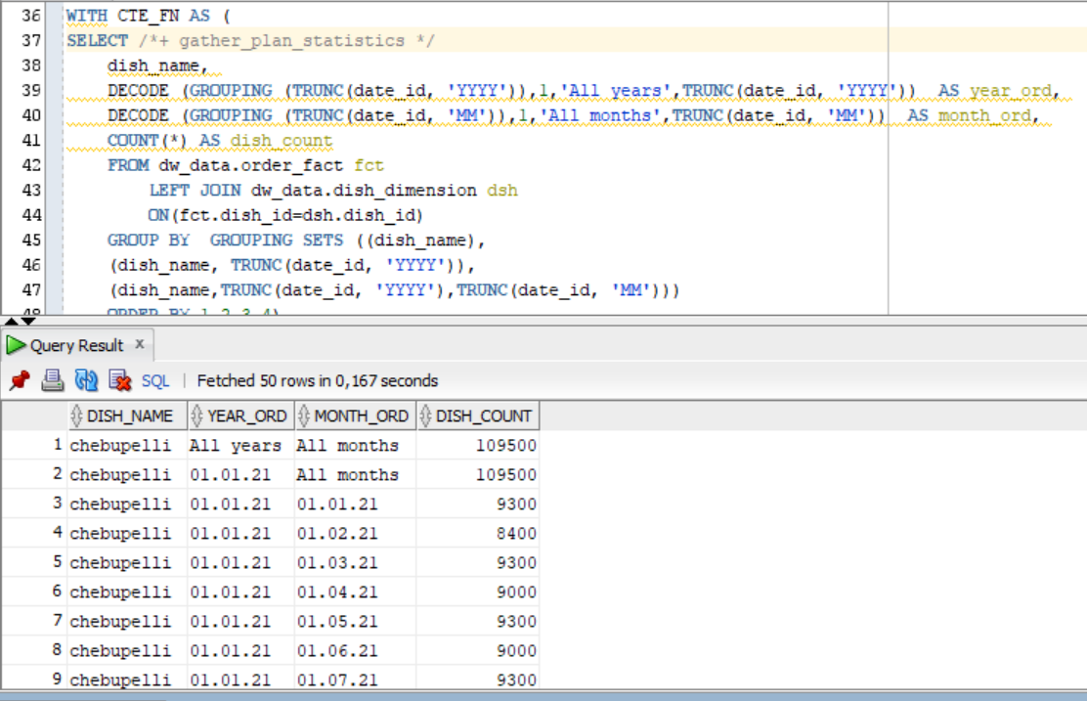

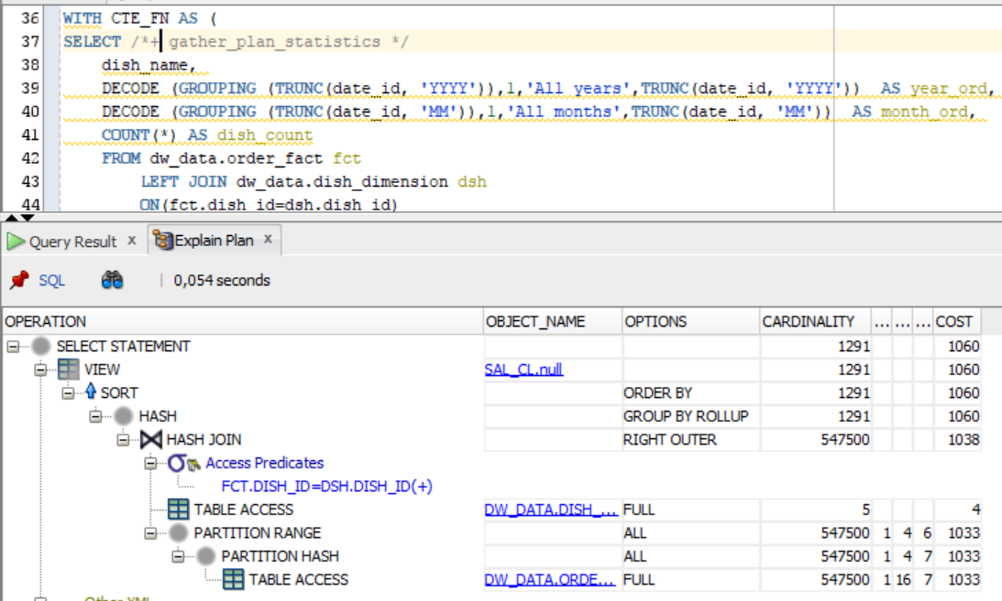

|  |  |  |  |  |
| --- | --- | --- | --- | --- |
| № | Source Type | Explain Plan - Statistics | | Time, Sec. |
| Cardinality | Cost |
| 1 | Lab 2, Advancing Grouping | 1291 | 3166 | 0,21 |
| 2 | Lab 5, Model Clause | 1291 | 3171 | 0,25 |
| 3 | Lab 11, Star Schema | 1291 | 1060 | 0,167 |